**MUNICIPAL SOLID WASTE (MSW) POWER PLANT EXERCISE**

Use of the App Interactive Thermodynamics



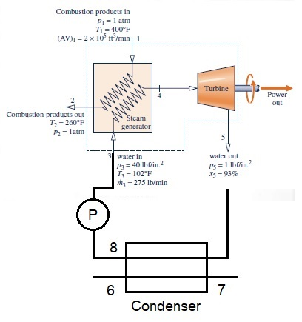.

Attention: Solve exercise on SI units and include a condenser and pump to complete the Rankine cycle. Consider water from a cooling tower to cool the condensation water by entering the condenser always at 298 K and atmospheric pressure. Consider the following aspects as well:

1. Size a hybrid incinerator with natural gas and municipal solid waste to provide the required volumetric flow rate of gaseous combustion products;

2. Initially output the cooling water from the condenser, T7, equal to T5, which is the maximum possible, and calculate the cooling water flow rate required for this. Study what happens if you decrease T7. Discuss the subject;

3. Calculate the resulting iso-entropic efficiency in the turbine. Estimate the extra power obtained by making the pressure at the outlet of the turbine be below the atmospheric, using a vacuum system;

4. Size the Steam Generator (Boiler) and Condenser with the NTU-effectiveness method, treating both with the working fluid performing full phase change, i.e., calculate the steam generator and condenser thermal conductances, UASG and UAcond. Determine the effectiveness of the two heat exchangers;

5. Calculate the exergy rate destroyed by the system, , and the 2nd Law efficiency of the cycle, . Study the impact of the incinerator gas pressure variation with p1 ranging from 1 to 4 bar on . What happens?

6. Are there opportunities to optimize the system? Give some suggestions and explain why you expect this effect.

NOTE: All students are required to submit a full report on this exercise.