CATIA Basics

Detailed Steps

Table of Contents
Manipulating Objects 3
Step 1: Start and Open a document 3
Step 2: Change the Part Number 5
Step 3: Change graphic properties 7
Step 4: Open a new Document 10
Step 5: Copy / Paste a PartBody 11
Step 6: Modify a feature 12
Step 7: Use the Compass 13
Step 8: Hide and delete a Body 15

Manipulating Objects
In this exercise you will learn basic tools to manipulate documents and get familiar with standard CATIA V5 interface.
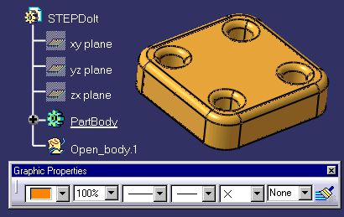

Step 1: Start and Open a document
- Start Catia.
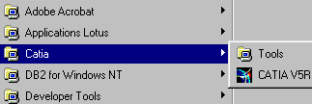
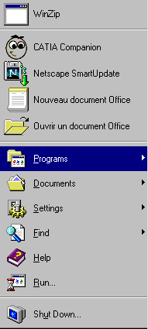
- Open CATCOMStep-dolt.CATPart and select mm as model unit by going to Tools + Options + General + Units.
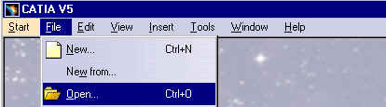
You must get:
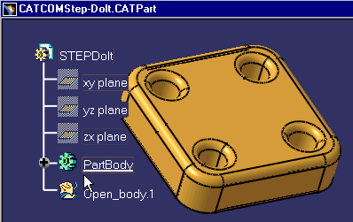

Step 2: Change the Part Number
- Save as the filename
- Select File / Save as.
- You can toggle Save as new document to specify a new internal identifier.
- Regenerating internal identifiers will avoid instantiation conflicts in Assembly Design.

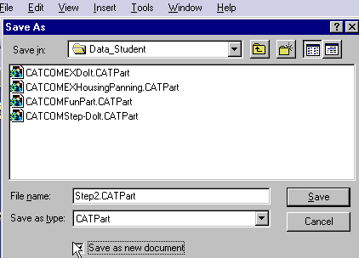

If you select Save as new document, you must close the CATCOMStep-Dolt.CATPart and open the new document Step2.CATPart.
- Change the part number.
- To change the part number, select on the Tree ‘Part Number’ and with MB3 choice Properties.
- You can click Alt +Enter to get the same following window:
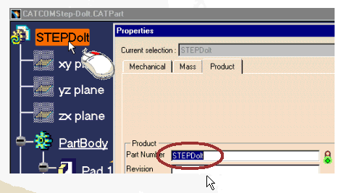
- See the next image to verify the good result.
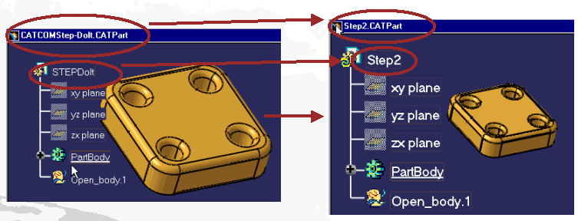

Step 3: Change graphic properties
- Change color of 5 faces.
- First, display the Graphics Properties Toolbar.
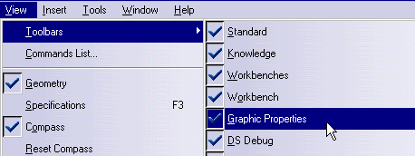

- Keeping the Key Ctrl pressed, select 5 faces and change theirs color.
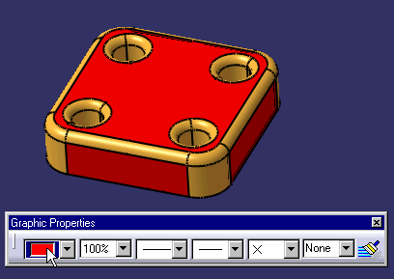
- Apply a material
- Select the appropriate icon .
Choice Silver and then click on the top of the Tree (you can select the Part Body).
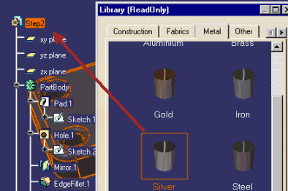
To render on the workbench the material, go to View / Render/ Apply Customized View.
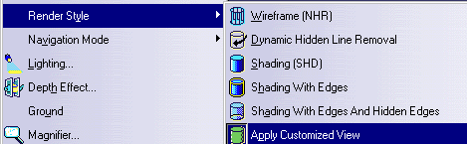
and select Materials: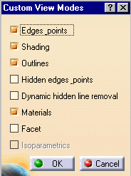
You must get this appearance: 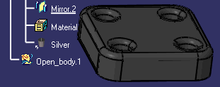
You can select too this icon  on the View Toolbar.

Step 4: Open a new Document
- Open New Part
- Select File / New. Name it Copy.
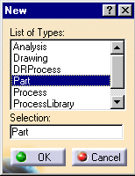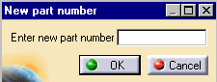
- Select Window / Tile Vertically.

Step 5: Copy / Paste a PartBody

- Select on the Tree the PartBody of Step2.CATPart in order to copy it.
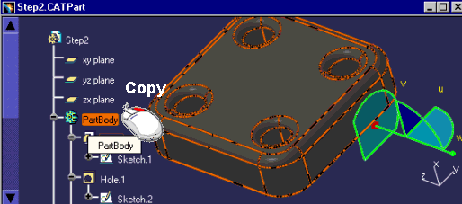
- Paste it on the second part ‘Copy.CATPart’
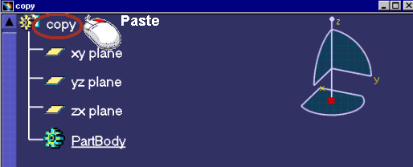

You must get: 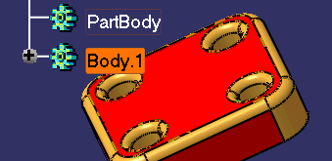

Step 6: Modify a feature

- Change the length of the Pad1 to 10mm.
- Go to Pad1 feature and double-click to edit it

The value must be change to 10 mm: 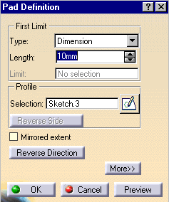

Step 7: Use the Compass

- Copy / Paste of Body.1.
- You are going to create a new Body.
- Click with MB1 on Tree and select Body.1.
While MB1 pressed, click the key Ctrl and drag it to the Top of the Tree in order to paste Body.1.
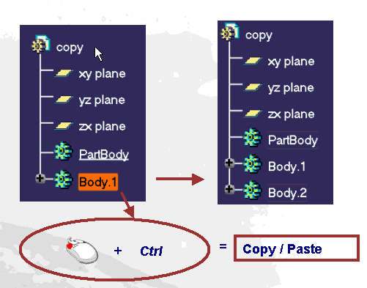
- Use the compass to drag Body.2.
- First with MB1 select the origin of the Compass ( red square).
See next image :
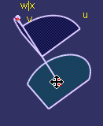
- Drag the compass while keeping MB1 pressed, and select the red surface.
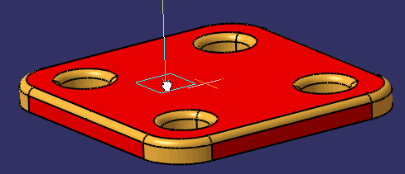
- The compass is now green.
With MB1 select Body.2 on the tree and then select Z axis of the compass and drag Body.2 along it.
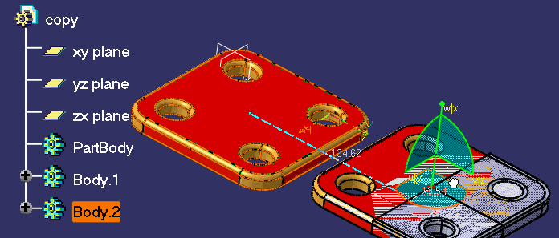

Step 8: Hide and delete a Body
- Close Step2.CATPart.
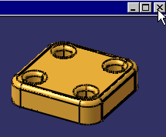
- Click with MB1 the ‘Close icon’ of the document window.
- Hide Body2.
Select first Body.2 with MB1.
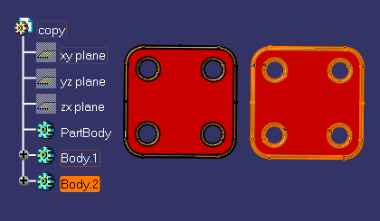
Place mouse curse on the empty background and click on MB3.
The Window Hide /Show appears.
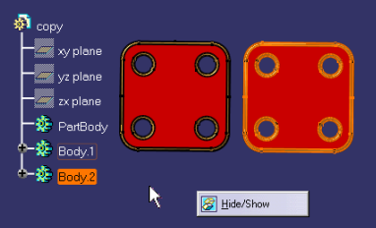

- To delete Body.2 , select Body.2 and click on the Keyboard the Key ‘Delete’.

